**Knowledge Stack**

GLM

<https://www.guru99.com/r-generalized-linear-model.html?fbclid=IwAR1fXvtDZMGCm7bDwtyb3uZTYHxZvlGbipFzeWwxTxjHKv_hKBTWSzdzbN8>

github

<https://github.com/facebookresearch>

mlops Andrew ng

* <https://www.youtube.com/watch?v=06-AZXmwHjo&ab_channel=DeepLearningAI>

for future me:

1. Check out top viewed video on firebase youtube channel, something about top tips. Got JSON beautifier inside

Forecasting

<https://otexts.com/fpp2/bootstrap.html>

dev ops

<https://www.youtube.com/watch?v=5pxbp6FyTfk&ab_channel=DevOpsJourney>

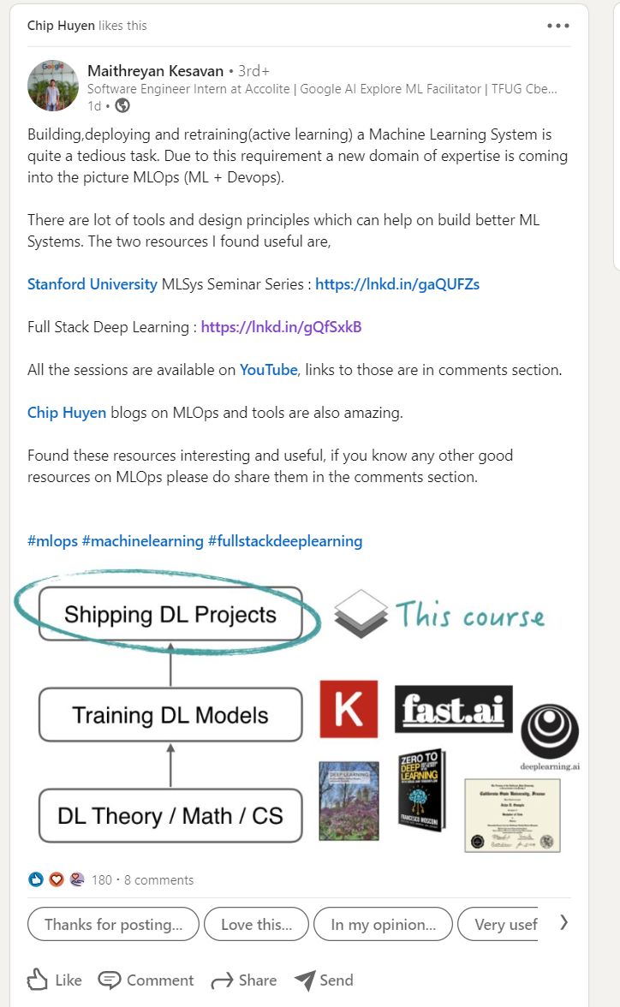

1. <https://mlsys.stanford.edu/>
2. <https://fullstackdeeplearning.com/>

General Data Science

<https://read.oecd-ilibrary.org/science-and-technology/scoping-the-oecd-ai-principles_d62f618a-en#page19>

<https://oecd-opsi.org/wp-content/uploads/2019/11/AI-Report-Online.pdf>

<https://oecd-opsi.org/projects/ai/strategies/>

<https://www.palantir.com/partnerships/data-providers/>

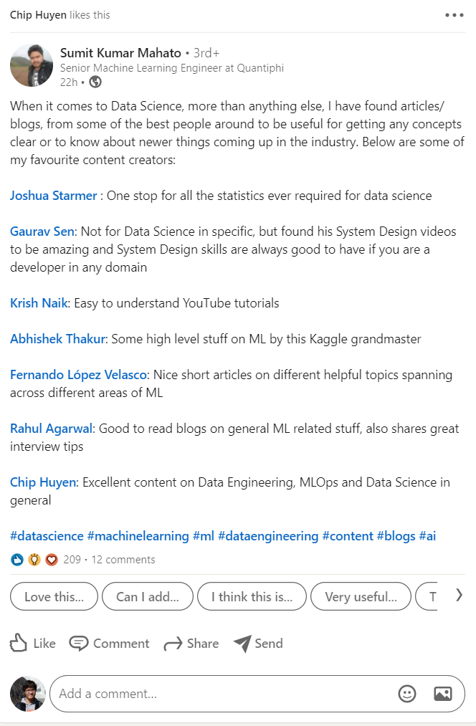

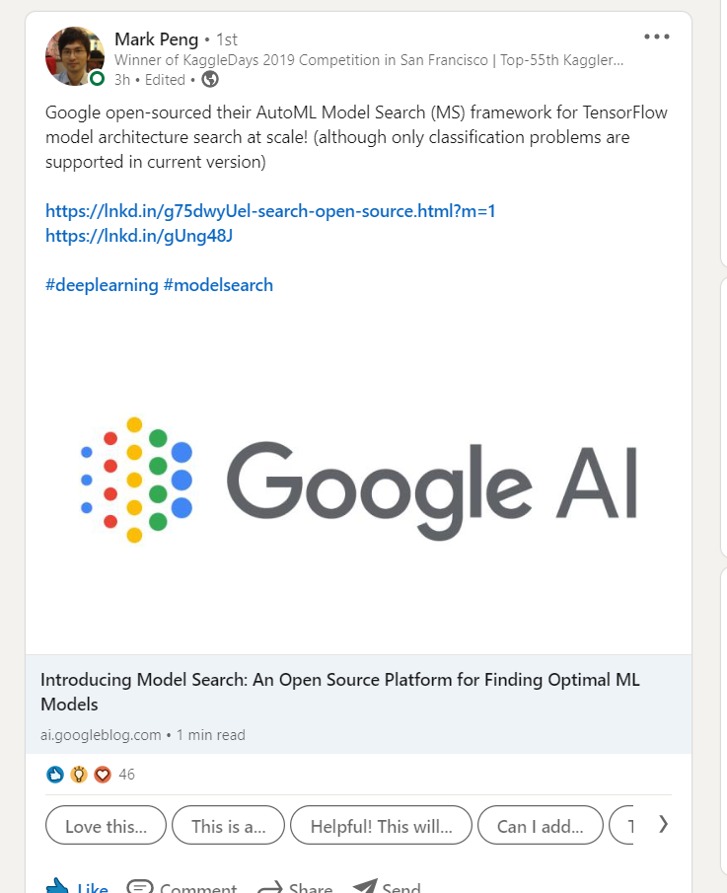

Computer Vision

Natural Language Processing

Isaac

1. <https://www.eu-startups.com/2020/04/helsinki-based-logmore-bags-e4-5-million-for-its-qr-data-logger/>
2. <https://craft.co/logmore/competitors>

Web analytics

1. [Chapter 2: Analytics (Funnels, Cohorts, Event Trends) (webengage.com)](https://webengage.com/blog/chapter-2-marketing-analytics-funnels-cohorts-events/)

Server

Dev tools

1. [What’s the Difference Between Containers and Virtual Machines? | Electronic Design](https://www.electronicdesign.com/technologies/dev-tools/article/21801722/whats-the-difference-between-containers-and-virtual-machines)

Data Analytical/Visualization

Cloud computing

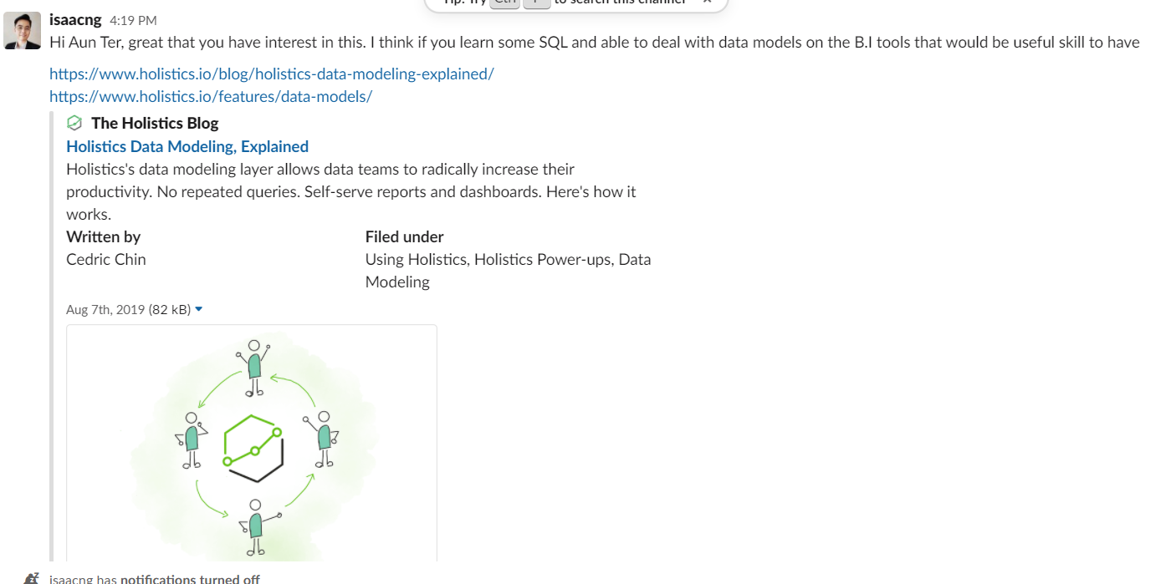

Finance

1. <https://www.linkedin.com/learning/financial-modeling-foundations/using-excel-for-financial-modeling>

data cleaning

<https://machinelearningmastery.com/books-on-data-cleaning-data-preparation-and-feature-engineering/>

Useful free course

1. AWS launches free eight-week app development training series on Twitch
   1. Ep 1: [AWS - Twitch](https://www.twitch.tv/videos/891956043?filter=archives&sort=time)
2. Google: Learn cloud skills for free with our new training tracks.
   1. Cloud, AI, Bigquery, Kubernetes, and containers



Models – supervised

Models – unsupervised

1. [Auto-Encoder: What Is It? And What Is It Used For? (Part 1) | by Will Badr | Towards Data Science](https://towardsdatascience.com/auto-encoder-what-is-it-and-what-is-it-used-for-part-1-3e5c6f017726)

Full stack data science code examples

1. [Mechanisms of Action (MoA) Prediction | Kaggle](https://www.kaggle.com/c/lish-moa/discussion/201510), [Fork of Blending with 6 models(5old-1new) | Kaggle](https://www.kaggle.com/nischaydnk/fork-of-blending-with-6-models-5old-1new), [Github code](https://github.com/guitarmind/kaggle_moa_winner_hungry_for_gold/blob/main/final/Best%20CV/Training/2heads-resnest-train.ipynb)

Full stack web development

1. [Fullstack React GraphQL TypeScript Tutorial - YouTube](https://www.youtube.com/watch?v=I6ypD7qv3Z8&ab_channel=BenAwad)
2. Techwithtim react Django
3. <https://www.geeksforgeeks.org/mern-stack/> - MERN Stack

Mark Peng curriculum

Very high level certificates – aim to take it in 3 years (?)

AWS Certified Machine Learning – Specialty (score: 913/1000)  
AWS Certified Solutions Architect – Associate (score: 940/1000)

Certificates:  
* Tensorflow in Practice, deeplearning.ai  
* Data Science: Data to Insights, MIT, edX verified (score: 100)  
* The Analytics Edge, MIT, edX verified (score: 97)  
* Statistical Learning, Stanford Online  
* Mining Massive Datasets, Stanford certificated, Coursera (with Distinction)  
* Machine Learning (by Andrew Ng), Stanford certificated, Coursera (score: 100)  
* Neural Networks for Machine Learning (by Geoffrey Hinton), Coursera (score: 100)

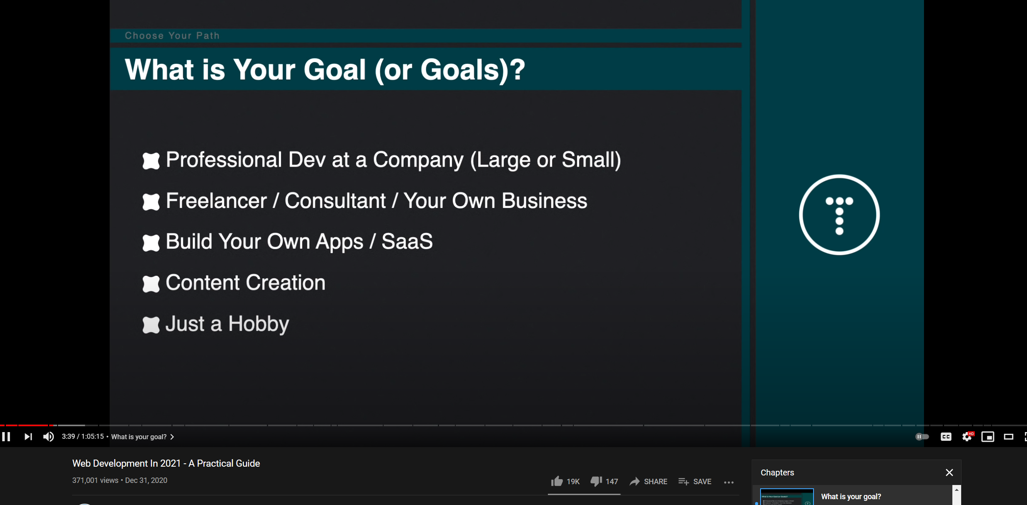

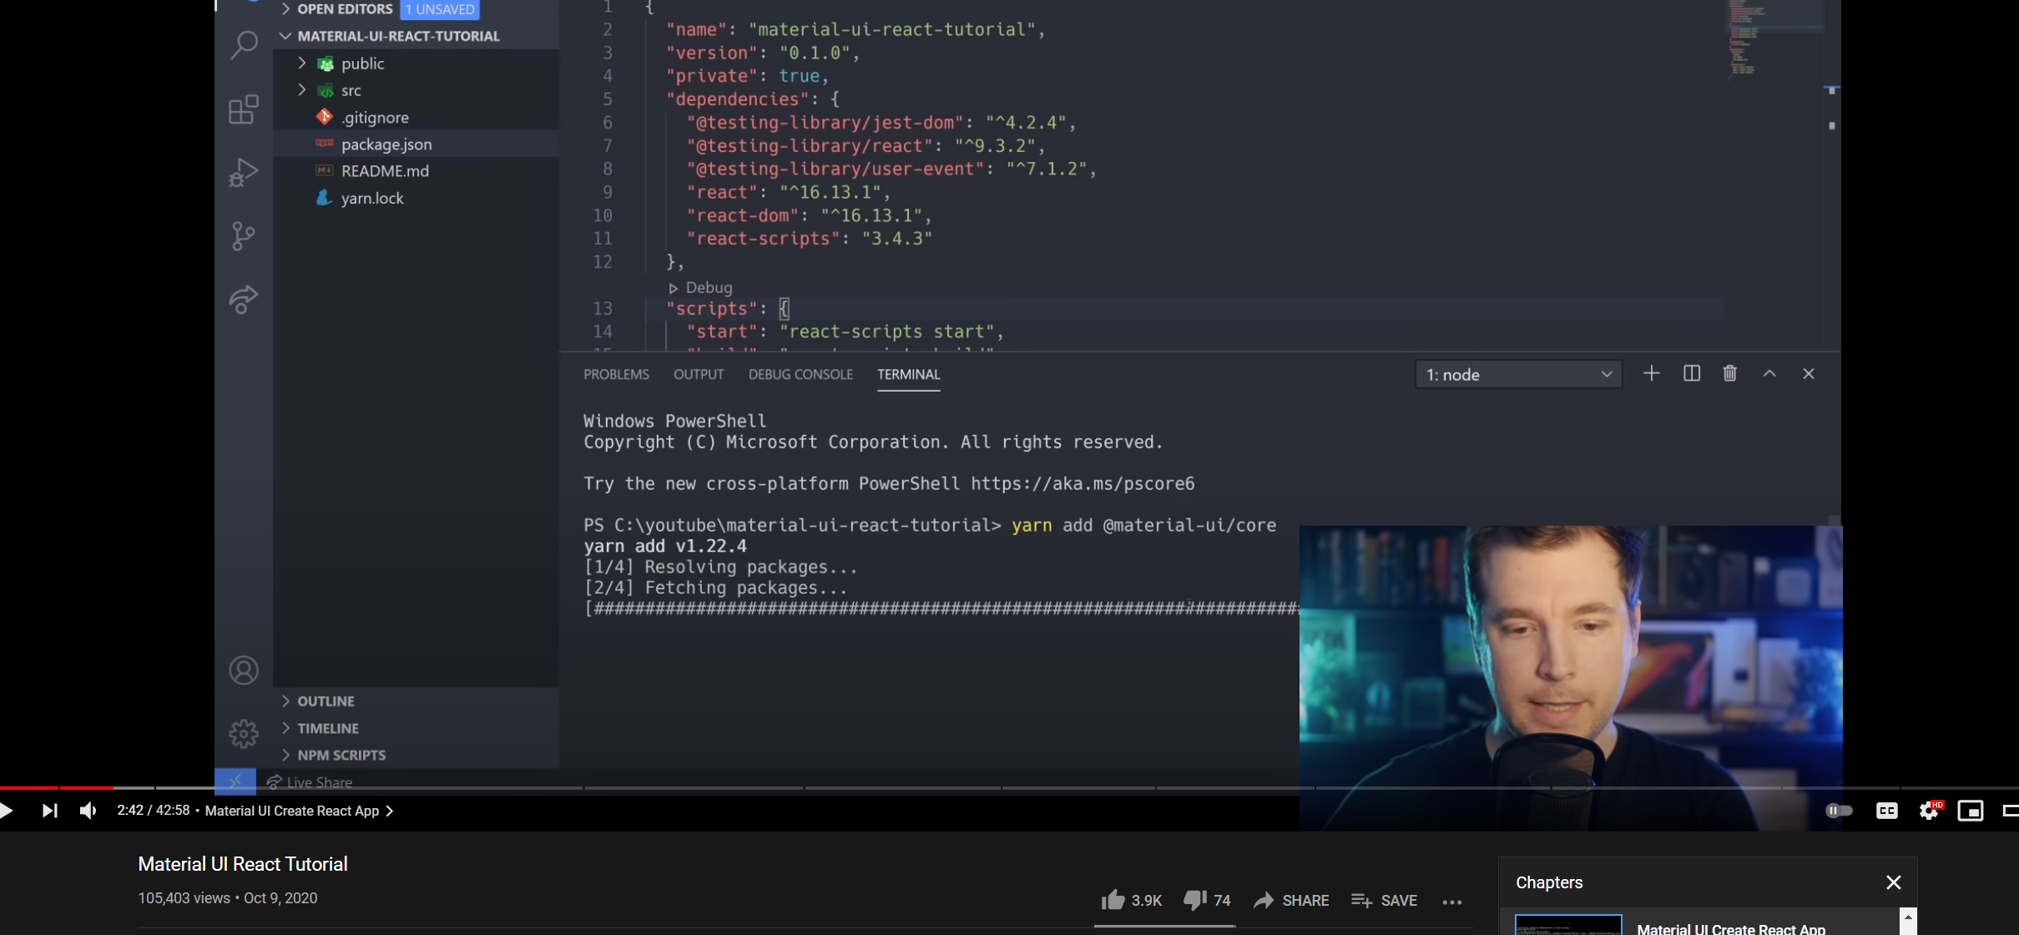

Udemy course on Django

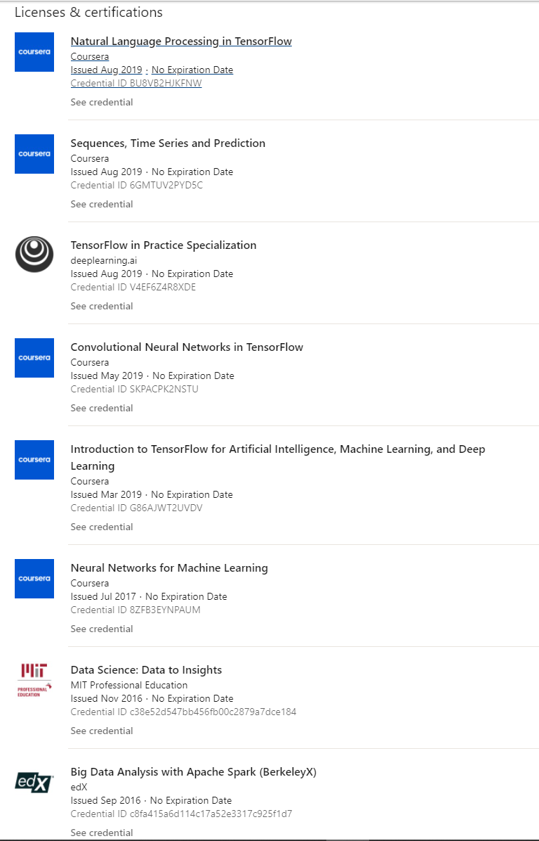

Kaggle

1. [How to make data science project with kaggle](https://www.youtube.com/watch?v=m2DfpM6MyB8&ab_channel=GoogleCloudPlatform)

AWS

<https://pages.awscloud.com/GLBL-gc-600-data-flywheel-learn.html#Turning_flywheel>

<https://mail.google.com/mail/u/1/#inbox/FMfcgxwLsSXVvrQDMvMTcBPDZwjtmlKl>

Firebase course

https://fireship.io/courses/react-next-firebase/

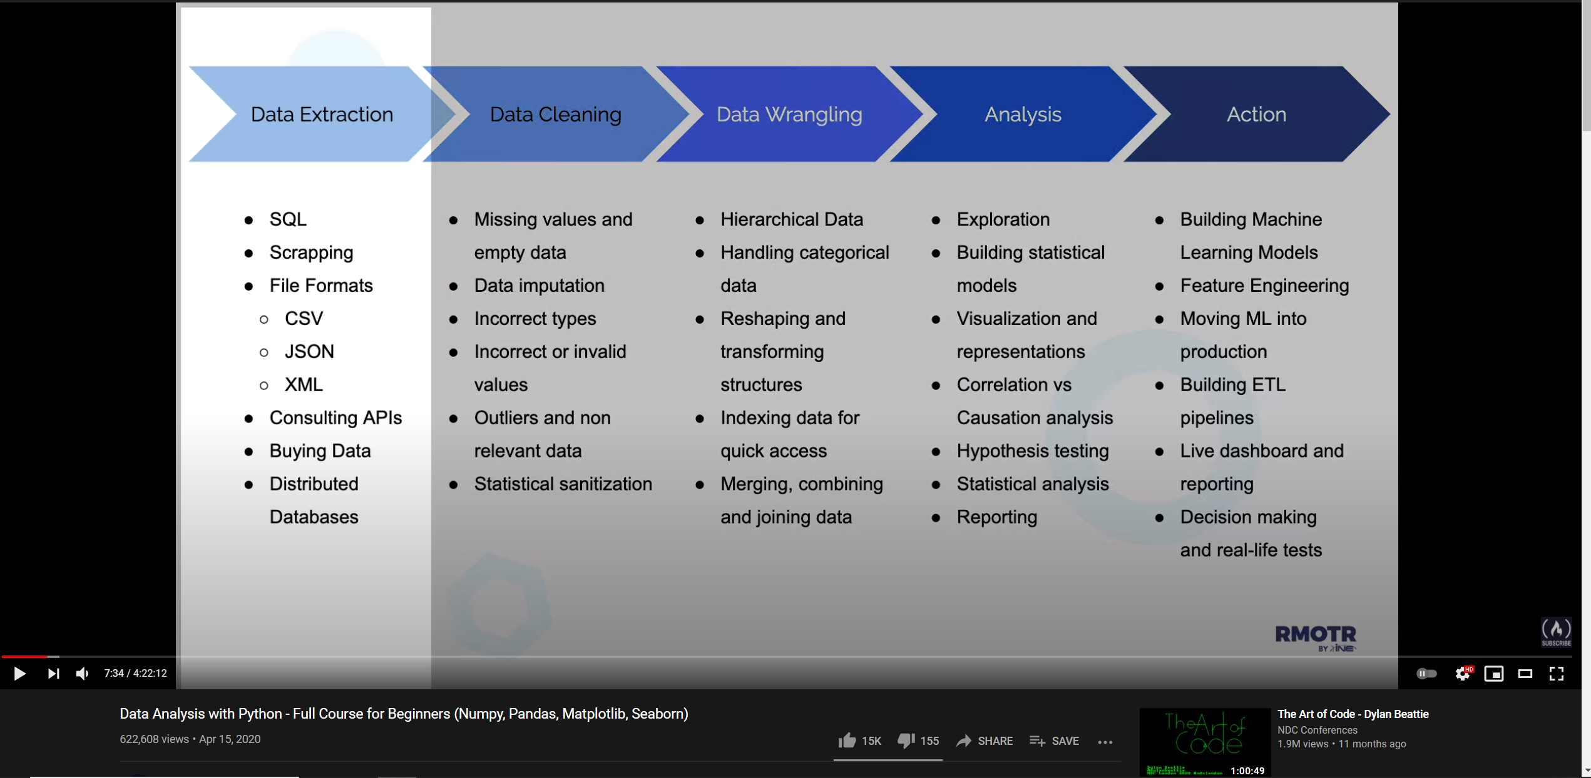

The action tab is probably more important to me

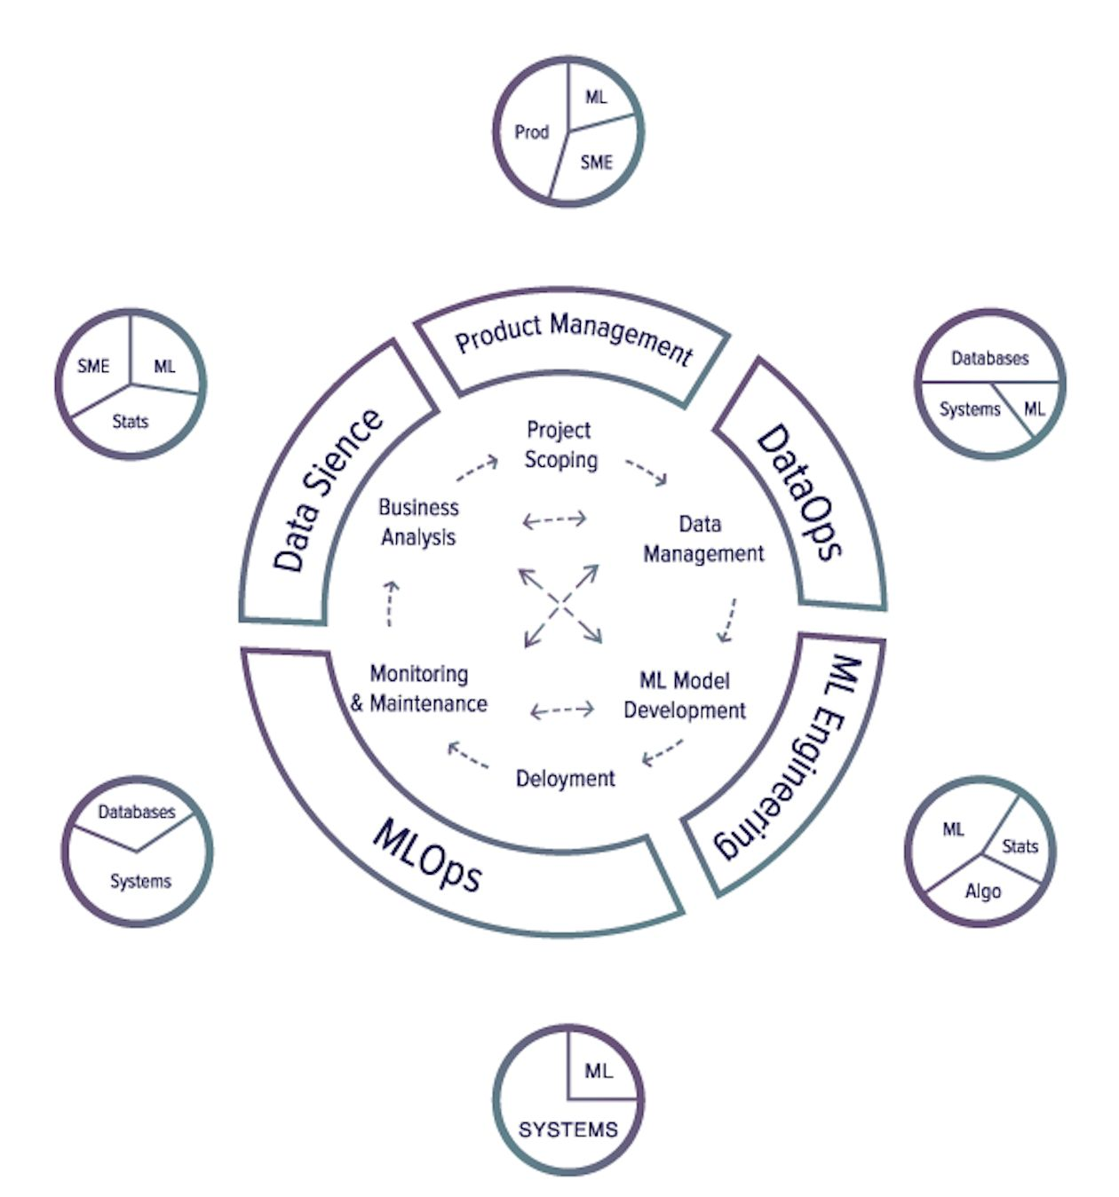

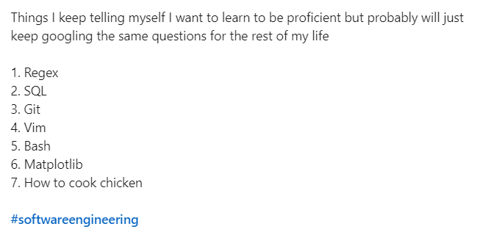

Create a panda github page

“my pandas is better than yours”

“comprehensive pandas”

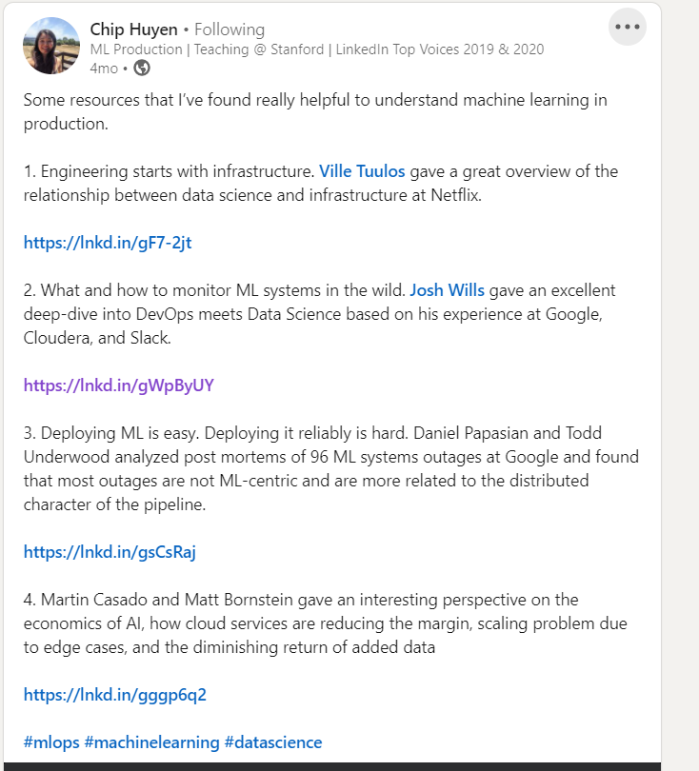

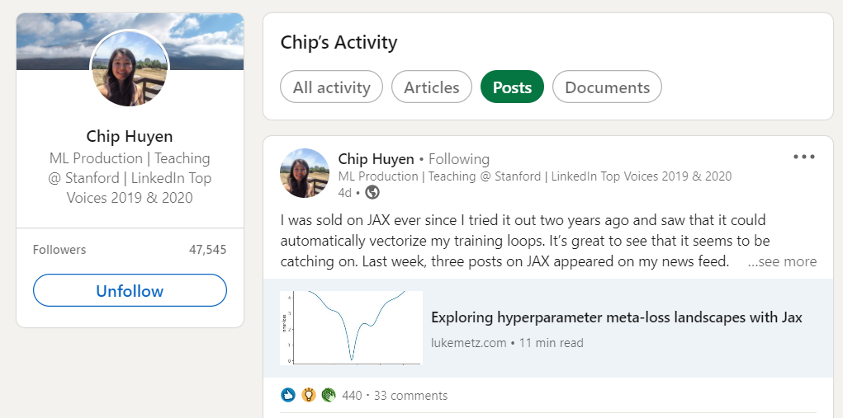

Good content creator

<https://web.stanford.edu/class/cs20si/syllabus.html>

<https://cs231n.github.io/convolutional-networks/>

<https://github.com/tensorflow/tensor2tensor>

## chip huyen

<https://stanford-cs329s.github.io/index.html#overview>

<https://huyenchip.com/machine-learning-systems-design/toc.html>

<https://snorkel.ai/machine-learning-production-myths/>

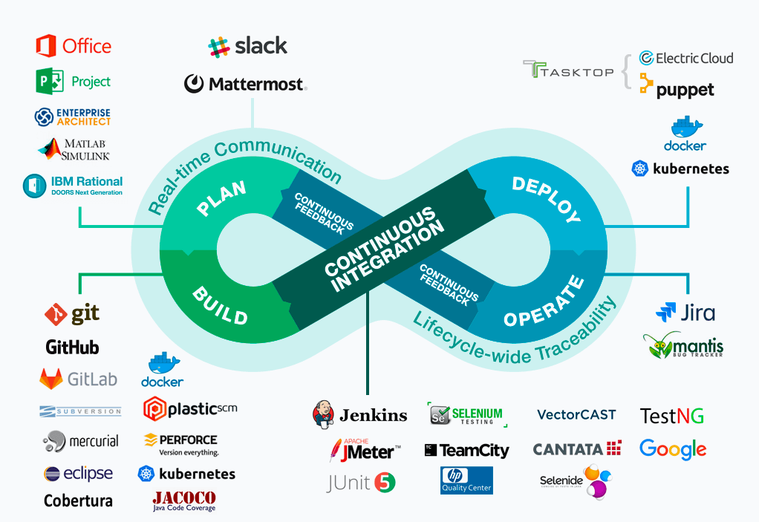

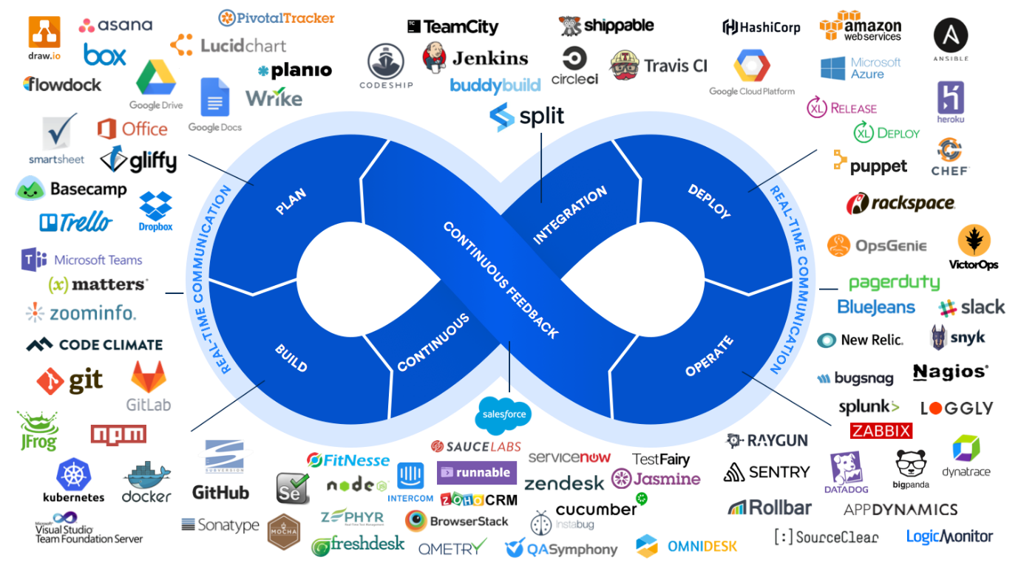

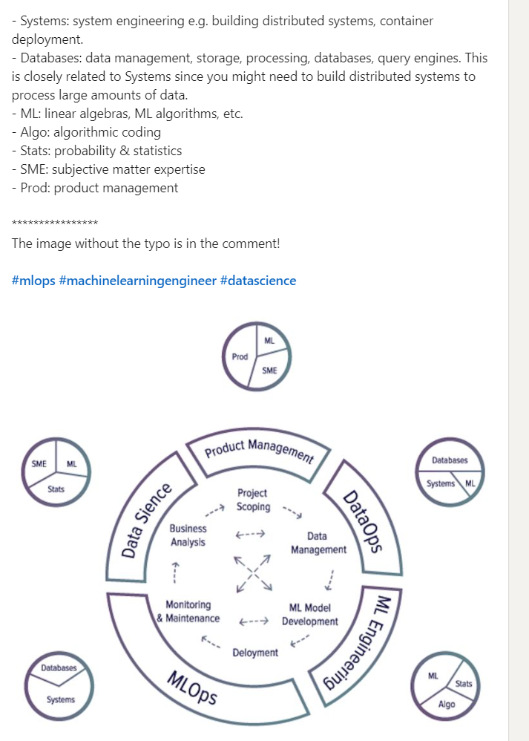

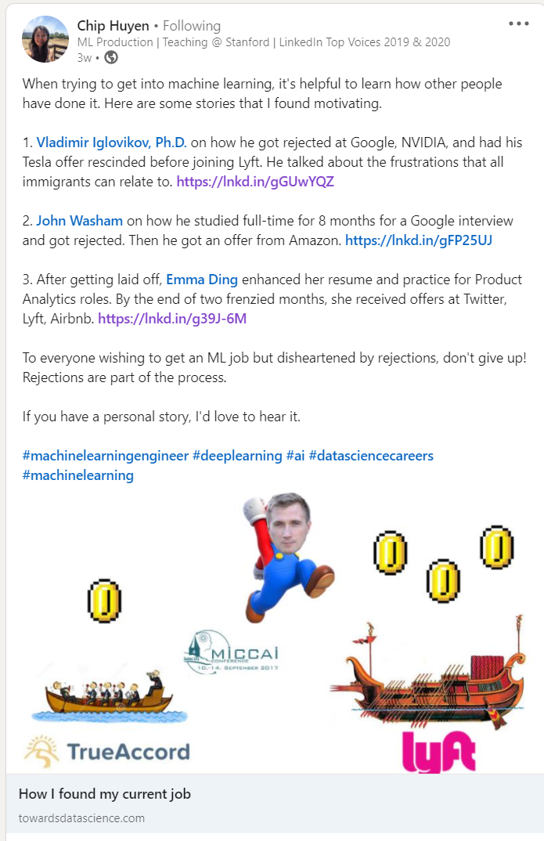

systems design

<https://www.geeksforgeeks.org/system-design-netflix-a-complete-architecture/>

data engineering

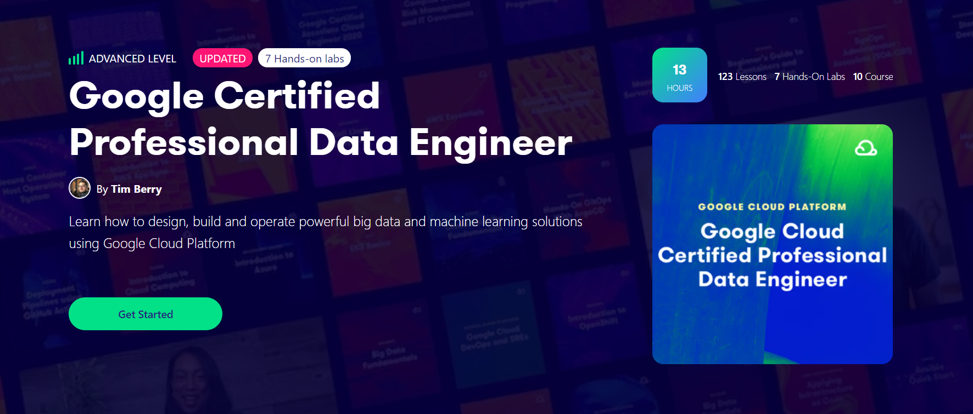

Kaggle

<https://www.kaggle.com/learn/overview>

google certificates

<https://grow.google/projectmanagement/#?modal_active=none>

<https://grow.google/dataanalytics/#?modal_active=none>

GIS

<https://earthworks.stanford.edu/catalog/stanford-zd362bc5680>

<https://www.google.com/search?q=malaysia+MUKIM+GIS+shapefile+polygon+boundary+layer&oq=malaysia+MUKIM+GIS+shapefile+polygon+boundary+layer&aqs=edge..69i57j69i64.8167j0j4&sourceid=chrome&ie=UTF-8>

<https://github.com/heiswayi/malaysia-postcodes/blob/master/ALL-POSTCODES.csv>

<https://data.humdata.org/dataset/malaysia-administrative-level-0-2-boundaries/resource/275956aa-99b3-4b32-b9c2-87db1fe0ca83>

<https://mygis.mysa.gov.my/sakura2/rest/services/Test_bnm/mukim/MapServer/export?bbox=100.45341008682031%2C-4.810696443836811%2C118.6965798858047%2C10.042752729565974&bboxSR=4326&imageSR=4326&size=1071%2C872&dpi=96&format=KML&transparent=true&layers=show%3A0&f=image>

<https://mygis.mysa.gov.my/sakura2/rest/services/Test_bnm/mukim/MapServer/export?bbox=99.640899163%2C-0.34784818302083576%2C119.26380449300001%2C8.564221321020835&bboxSR=4326&imageSR=4326&size=1920%2C872&dpi=96&format=kml&transparent=true&layers=show%3A0&f=image>

Geospatial

GIS with Python

1. <https://towardsdatascience.com/deep-learning-for-land-cover-classification-of-satellite-imagery-using-python-e7ca9f7bfa0a>

<https://vedas.sac.gov.in/vedas/downloads/ertd/31%20Advanced%20geospatial%20technology%2026-29nov2019/L2%20GIS_Analysis_Techniques_and_Multi_Criteria_Analysis.pdf>

<https://researchguides.dartmouth.edu/gis/spatialanalysis>

<https://mgimond.github.io/Spatial/chp09-0.html>

<https://www.esri.com/arcgis-blog/products/analytics/analytics/learn-spatial-analysis-techniques-with-scenario-based-case-studies/> (good)

<https://medium.com/locale-ai/the-five-most-unheard-applications-of-location-analytics-for-businesses-ab9947784330> (good examples)

<https://towardsdatascience.com/tagged/spatial-analysis> (list of articles)

<https://uxdesign.cc/how-to-choose-new-retail-location-by-leveraging-location-intelligence-fdf449e0932e> (search for the word “criteria”)

# Retail

Retail spatial analytics research questions

1. Household income and the retail stores nearby
2. Population surrounding the retail stores
3. How close are the retails to one another, and the category of stores that are close together
4. Do we have sales items for the specific stores?
5. Buffer analyses see what are the best features nearby
6. <https://www.google.com/search?client=safari&rls=en&q=Geospatial+Analytics+in+Retail+Site+Selection+and+Sales+Prediction+pdf&ie=UTF-8&oe=UTF-8> (good)
   1. <https://aip.scitation.org/doi/pdf/10.1063/1.5055554>
7. Site Selection of Retail Shops Based on Spatial Accessibility and Hybrid BP Neural Network
8. <https://mgimond.github.io/Spatial/spatial-autocorrelation.html>

Research papers

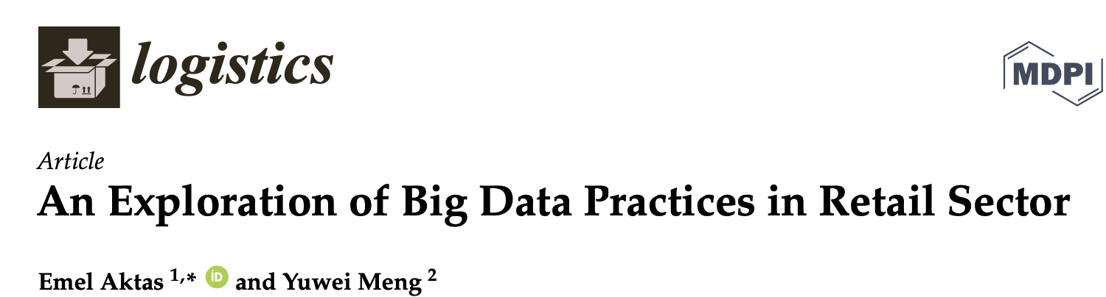

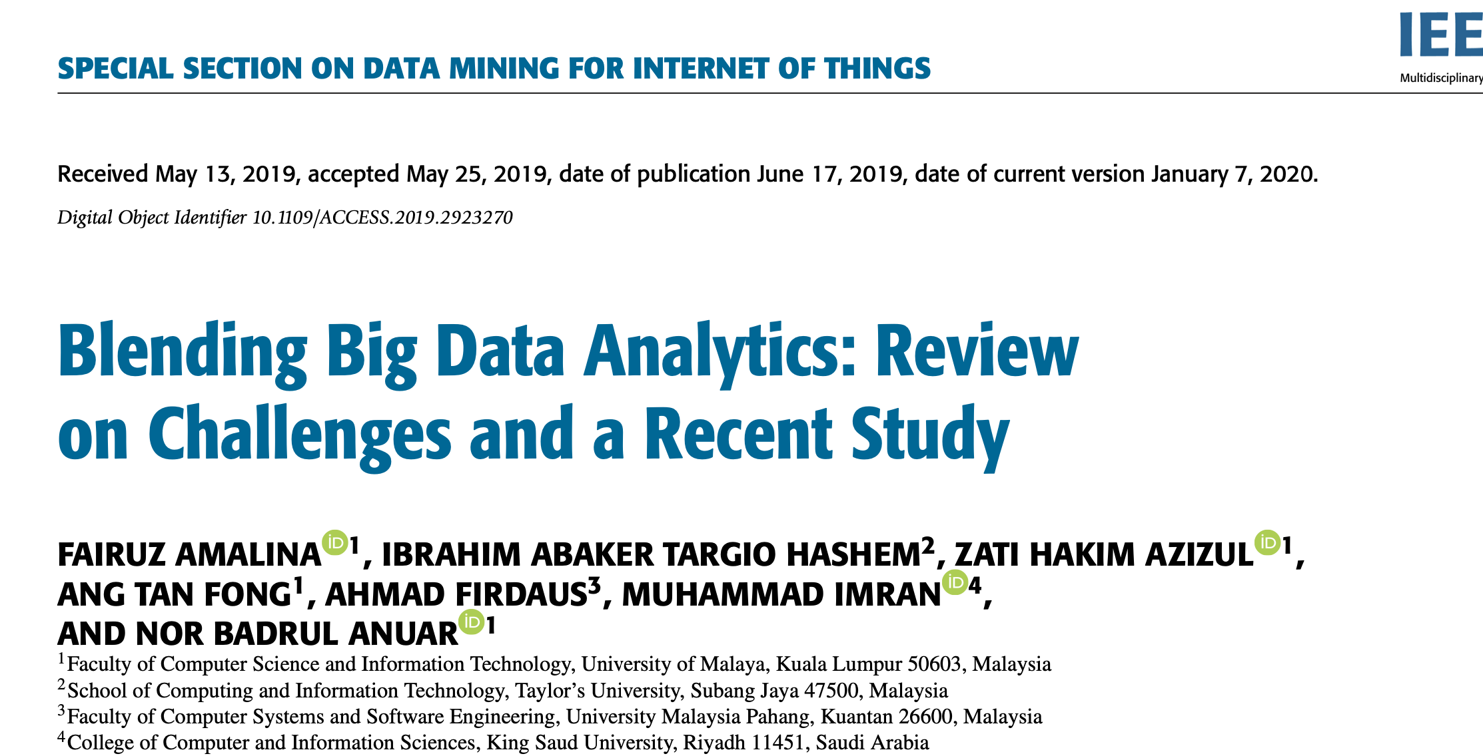

A lot of different case studies, Malaysian papers

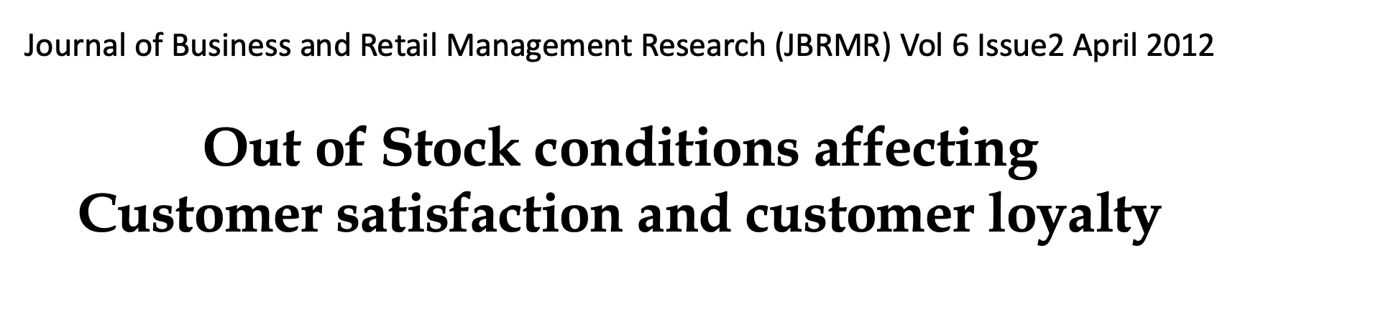

Google keyword “Geospatial Analytics in Retail Site Selection and Sales Prediction pdf

<http://scet.berkeley.edu/wp-content/uploads/UCBSCETRetailAnalyticsReport.pdf> (search for “**Companies providing analytics software offerings )**

<https://analyticsindiamag.com/how-geospatial-data-will-play-a-key-role-in-retail-analytics-in-the-post-covid-world/> (route and delivery)

Customer journey map

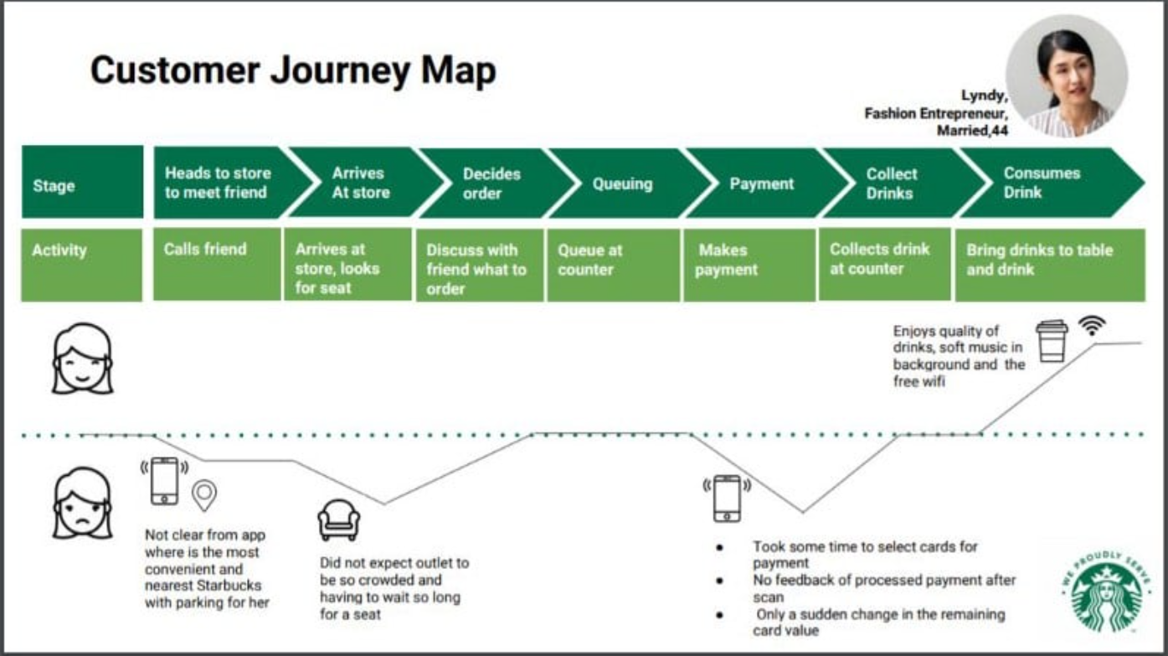

# Finance

Course on linkedin – financial statement analysis

<https://www.linkedin.com/learning/corporate-financial-statement-analysis/what-is-financial-statement-analysis>

# Google ads

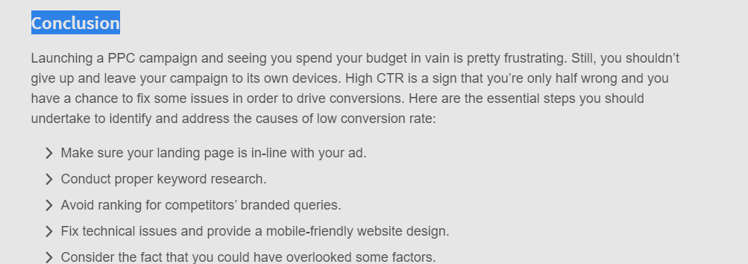

<https://www.storegrowers.com/set-up-google-ads/>

<https://www.youtube.com/watch?v=EeF0yWP4xp0&ab_channel=JasonWhaling>

<https://neilpatel.com/what-is-google-adwords/>

<https://blog.hubspot.com/marketing/google-adwords-ppc>

<https://www.reddit.com/r/adwords/comments/6uagha/setting_up_first_adwords_campaign_am_i_doing_this/>

* The most important thing in AdWords is keyword selection

<https://www.reddit.com/r/PPC/comments/6qqcc9/new_ultimate_adwords_guide_8_things_youre_gonna/>

Keywords - words or phrases that people type into Google Search (look for frequently used keywords)

Bid – How much you are willing to pay for an ad

Quality Score – relevance of keywords

## Deciding on which funnel to focus on

**You want a mix of high and low volume keywords**

Generally speaking, most keywords with higher average monthly searches will have more competition. But they will also be more general in nature, leading to fewer sales.

Having a mix of both will give you specificity and tons of traffic that you can remarket.

The key with keywords (pun intended) is to analyse intent behind the search.

Always analyze the intent behind a keyword before you run with it.

Match keywords directly to your campaign goals.

If you want to sell more shoes in this campaign, focus on keywords that are lower in the funnel. If you want to educate people about your shoe brand, target top of the funnel review searches.

After compiling a big list of potential keywords using the keyword tool, you can move on to using a few more tools that can help you dig deeper into potential ideas by investigating your competition.

List of online tools

1. Keywordtool.io
2. Spyfu.com

## Negative keywords list

1. <http://www.clixmarketing.com/blog/wp-content/uploads/2008/02/worlds-biggest-negative-keyword-list.txt>
2. <https://www.reddit.com/r/PPC/comments/oz1av/open_source_negative_keyword_list/>
3. <https://docs.google.com/spreadsheets/d/1e7PgRbT1S6aaVj8NC_ynhWUh2By39PD9U4-X7w69Lqk/edit#gid=4>

Front-end

1. HTML
2. CSS
3. Svelete/React

Backend

1. Django
2. Laravel (lowest prio)

Database

1. Mongo
2. Any

## Before Mass Clean up

### House Pump Location

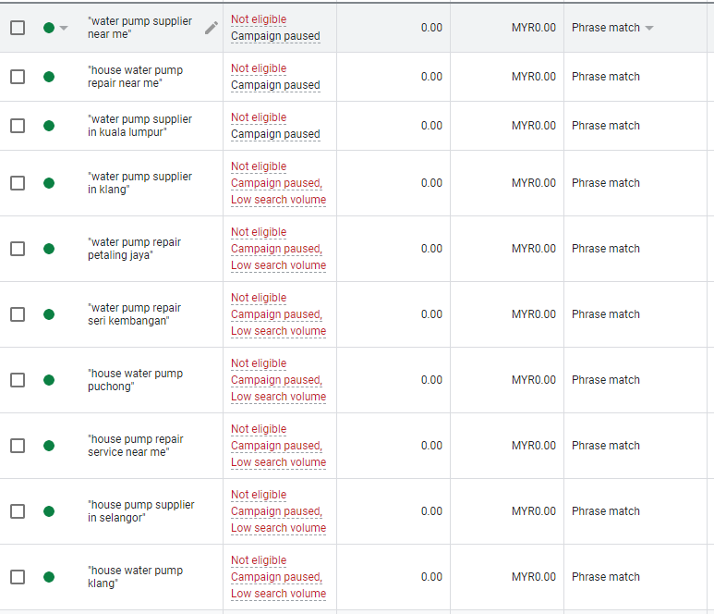

## Water pump – location phrase

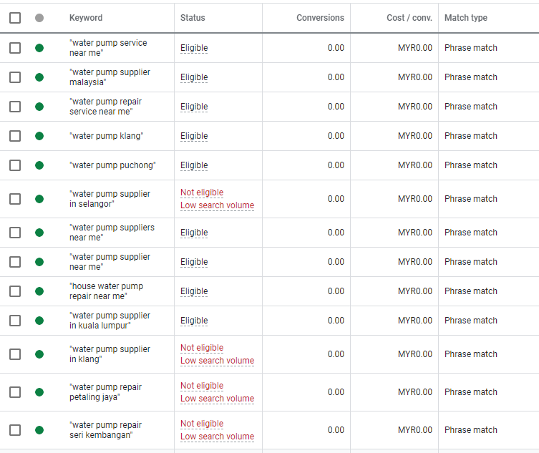

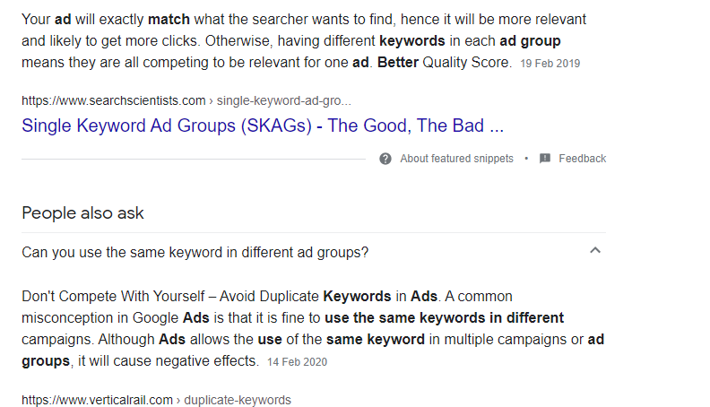

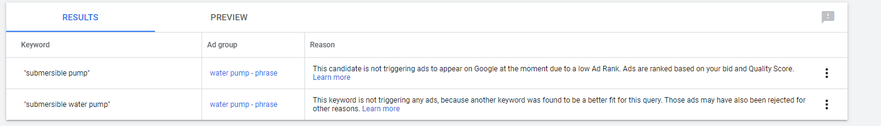

Why are my ads not showing

1. Low quality score
2. Low bid

https://www.youtube.com/watch?v=ESINIb-HO7k&ab_channel=SurfsidePPC

1. Increasing your bids
2. Look at quality score
   1. Go to keywords
   2. Go to modify columns
   3. Go to quality score
   4. Check all the boxes
   5. You generally want to be 7/10 and above
   6. Check expected CTR

Quality Score is an estimate of how relevant your ads, keywords, and landing page are to a person who sees your ad. High Quality Scores typically lead to lower cost and better ad position

## Null Quality Scores

<https://www.ppccourse.com/quality-score-not-showing/>

**Similar keywords in one ad group or multiple ad group**

<https://support.google.com/google-ads/answer/2756257?hl=en>

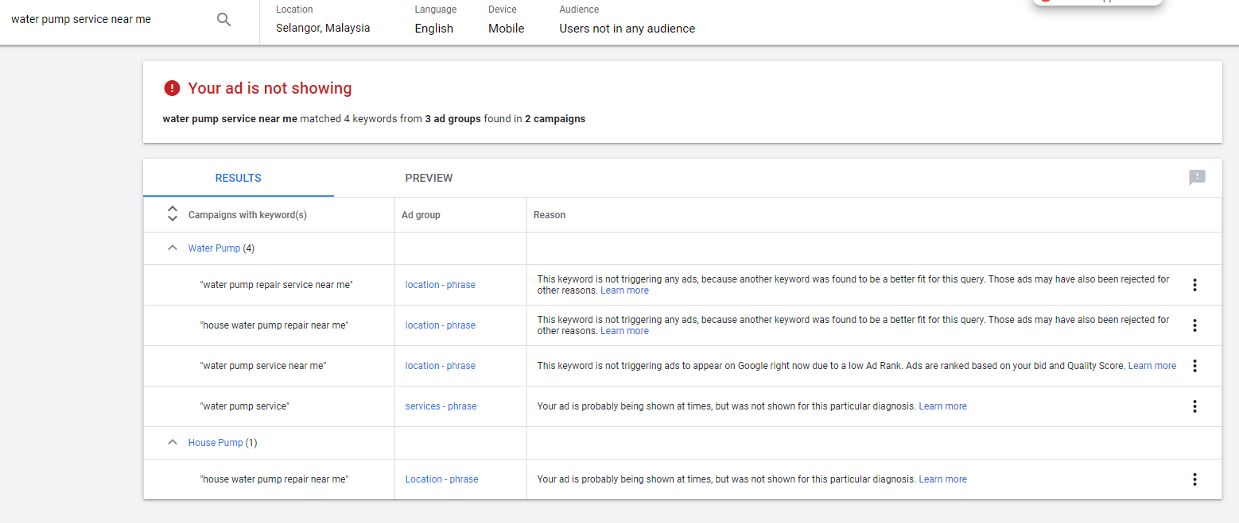

## Optimisation score

What is the acceptable optimisation score?

>80%

High CTR but low conversoin

## Troubleshoot

Power Pump 12/5/2021

* High CTR but low conversion
  + Too broad keywords (?)
  + Landing page not optimized

Water pump campaign – gathering a lot of clicks

1. Ad group
   1. Services – phrase
   2. Product – phrase

# VBA EXCEL

<https://excel-macro.tutorialhorizon.com/excel-vba-insert-multiple-images-from-a-folder-to-excel-cells/>

<https://www.mrexcel.com/board/threads/using-vba-to-pull-images-from-folder-to-sheet.1156613/>

# Computer vision

The Batch: Rise of the Robocoders, Banks Embrace Face Recognition, Toward Greener AI, Cloning 3D Objects

Mathematics

Standard Deviation

https://examples.yourdictionary.com/examples-of-standard-deviation.html

UNIX COMMAND CHEAT SHEET  
<http://www.mathcs.emory.edu/~valerie/courses/fall10/155/resources/unix_cheatsheet.html>